Parent Portal Launch

St Augustine’s Parish Primary School is excited to launch our Parent Portal.
Access is restricted to parents of students at our school and a logon is required. An account has been created for you and the details are outlined below.
The Parent Portal will enable easy access to information about happenings in the school, forms that need to be returned, names and contact details for staff, policy information and much more.
There’s also a special section to allow you to check the details we have recorded in our enrolment system about your children, and if necessary, advise us of any changes.
You can also check on information about your child’s attendance, teachers, timetable, NAPLAN performance and report cards.
We will be making increasing use of the Parent Portal to provide a range of information to parents in the future.
The initial login requires you to verify your identity and setup a password. This document will run you through the process.
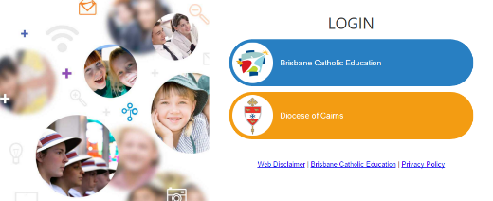
https://extranet.bne.catholic.edu.au/parent/sa
- Start the process by clicking on the link above. You will be met with a login screen.

- Select Brisbane Catholic Education and select Forgotten Password/First-Time Login

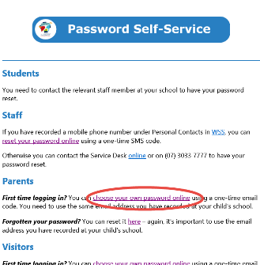
- Select the link under the Parents heading titled choose your own password online

- Enter the personal email address that you have provided to the school and click Next.

- Check your email for a security code and enter the corresponding security code in the screen that follows and click Next.

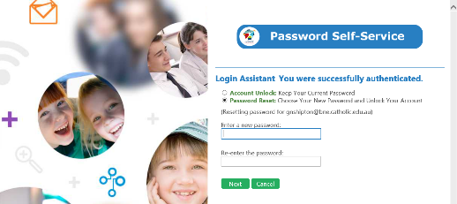
- Ensure that Password Reset option is selected and enter your desired password in both boxes before clicking Next.

- Now that you have set your password you can now login to the Parent Portal by following this link https://extranet.bne.catholic.edu.au/parent/sa

